CAPE NATURALISTE COLLEGE

ELECTRIC CIRCUIT AND SYMBOLS TEST

NAME _________________________ MARK /20

1. Name these (2 marks)
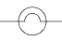
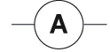
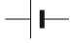
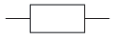

____________ _____________ _____________ _______________

2. Draw these (2 marks)
variable resistor closed switch

voltmeter fuse

3. Name all the parts in these circuits. (5 marks)
a)
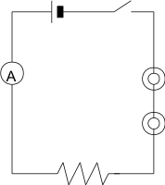
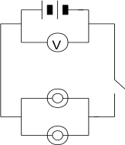

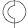

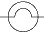

4. In 3.a) all parts of the circuit are in series. In 3. b) some parts of the circuit are in
parallel. Explain what "series" and "parallel" mean in electric circuits. (2 marks)

____________________________________________________________________
____________________________________________________________________
____________________________________________________________________

5. Complete the partly drawn circuit by adding
(i) a battery (3 cells) and a switch in series
(ii) an ammeter and a variable resistor in series
(iii) two globes in parallel
(iv) a wire crossing the circuit that is not joined (4 marks)
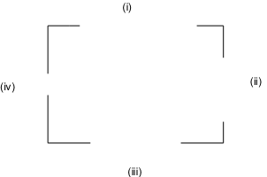

6. Examine the sketch of an electric circuit. Redraw the circuit using symbols in the space provided (Remember to use a pencil and a ruler) (5 marks)



